**Home page**

It wanted me to change the size of my logo but when I changed it to what it recommended it was too big for my page.

**Shop page**

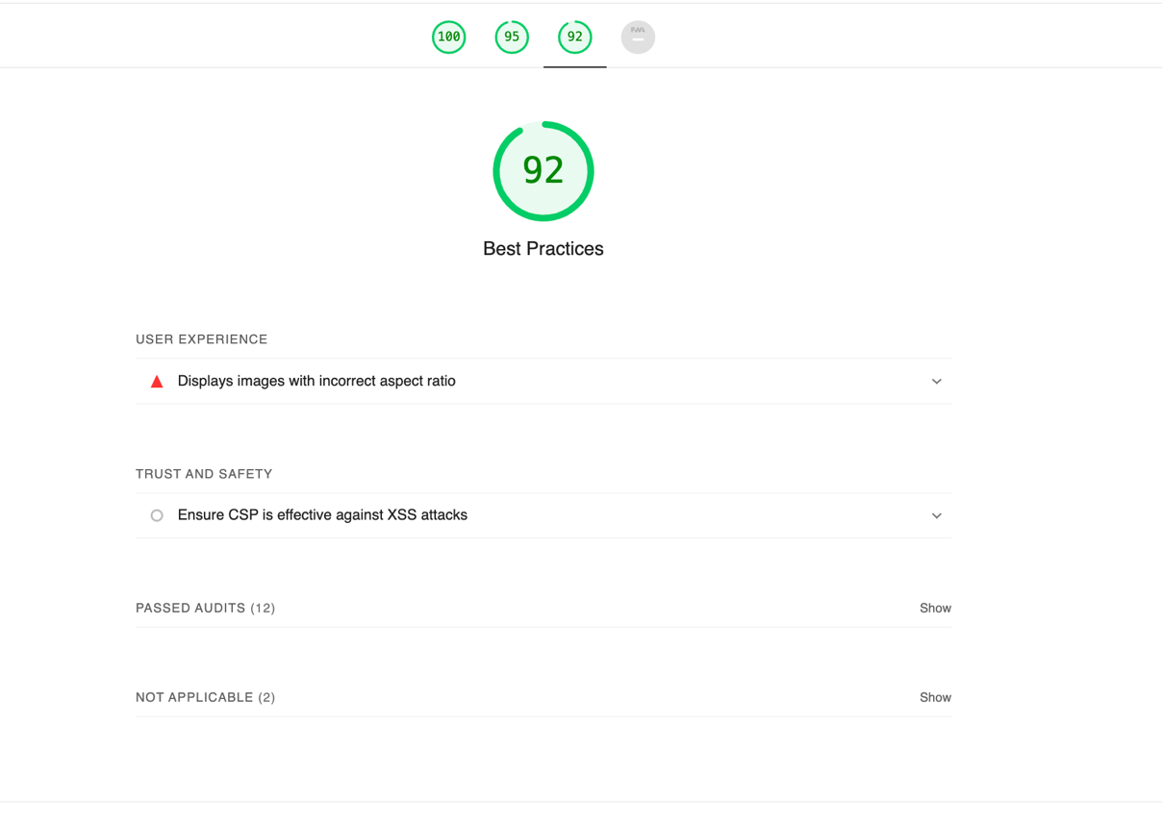

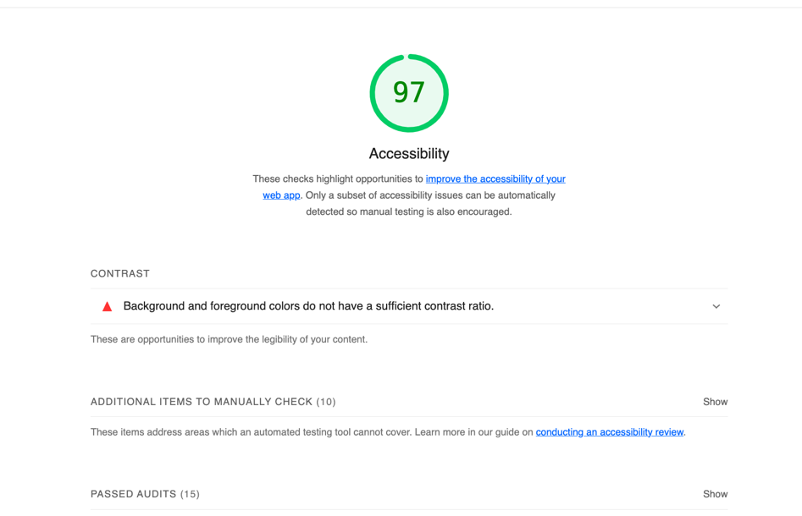

**Home Page:**

**Html Validator for home page**

**Every time if fix one of the errors, more errors pop up.**

**CSS Validator for home page**

**Shop Page HTML Validator**

**I don’t understand how these are not closed but are considered closed on the other lines?**

1. <!-- NAVIGATION -->↩
2. <nav class="navbar navbar-expand-lg navbar-light bg-white py-3 fixed-top">↩
3. <div class="container">↩
4. <img src="logo.jpeg" alt=" logo" width="100" height="100">↩
5. <h1>Tea House</h1>↩
6. <button class="navbar-toggler" type="button" data-bs-toggle="collapse" data-bs-target="#navbarSupportedContent" aria-controls="navbarSupportedContent" aria-expanded="false" aria-label="Toggle navigation">↩
7. <span><i id="bar" class="fas fa-bars"></i></span>↩
8. </button>↩
9. <div class="collapse navbar-collapse" id="navbarSupportedContent">↩
10. **<ul class="navbar-nav ml-auto">**↩
11. ↩
12. <li class="nav-item">↩
13. <a class="nav-link active" href="index.html">Home</a>↩
14. </li>↩
15. <li class="nav-item">↩
16. <a class="nav-link" href="shop.html">Shop</a>↩
17. </li>↩
18. ↩
19. ↩
20. <li class="nav-item">↩
21. <a class="nav-link" href="Contact-Us.html">Contact Us</a>↩
22. </li>↩
23. <li class="nav-item">↩
24. <i class="fal fa-search"></i>↩
25. <i onclick="window.location.href='cart.html';" class="fal fa-shopping-bag"></i>↩
26. </li>↩
27. ↩
28. **</div>**↩
29. </div>↩
30. </nav>↩
31. <!-- Products-->↩
32. <section id="featured" class="my-5 pb-5">↩
33. <div class="container text-center mt-5 py-5">↩
34. <hr class="mx-auto">↩
35. </div> ↩
36. **<div class="row mx-auto container-fluid">**↩
37. <div class="product text-center col-lg-3 col-md-6 col-12">↩
38. <img class="img-fluid mb-3" src="hibiscus.jpeg" alt = "">↩
39. <div class="star">↩
40. ↩
41. <i class="fas fa-star"></i>↩
42. <i class="fas fa-star"></i>↩
43. <i class="fas fa-star"></i>↩
44. <i class="fas fa-star"></i>↩
45. <i class="fas fa-star"></i>↩
46. </div>↩
47. <h5 class="p-name">Rose Hibiscus tea</h5>↩
48. <p>Fruity and sweet</p>↩
49. <p>with a hints of sour notes</p>↩
50. <h4 class="p-price">$15.99</h4>↩
51. <button class="buy-btn">Buy Now</button>↩
52. </div>↩
53. <div class="product text-center col-lg-3 col-md-6 col-12">↩
54. <img class="img-fluid mb-3" src="mint.jpeg" alt="" >↩
55. <div class="star">↩
56. <i class="fas fa-star"></i>↩
57. <i class="fas fa-star"></i>↩
58. <i class="fas fa-star"></i>↩
59. <i class="fas fa-star"></i>↩
60. <i class="fas fa-star"></i>↩
61. </div>↩
62. <h5 class="p-name">Mint Tea</h5>↩
63. <p>Earthy , clean and refreshing</p>↩
64. <h4 class="p-price">$10.99</h4>↩
65. <button class="buy-btn">Buy Now</button>↩
66. </div>↩
67. <div class="product text-center col-lg-3 col-md-6 col-12">↩
68. <img class="img-fluid mb-3" src="orange-lemonade.jpeg" alt="" >↩
69. <div class="star">↩
70. <i class="fas fa-star"></i>↩
71. <i class="fas fa-star"></i>↩
72. <i class="fas fa-star"></i>↩
73. <i class="fas fa-star"></i>↩
74. <i class="fas fa-star"></i>↩
75. </div>↩
76. <h5 class="p-name">Orange Lemonade Tea</h5>↩
77. <p>Citrusy and tart</p>↩
78. <h4 class="p-price">$19.99</h4>↩
79. <button class="buy-btn">Buy Now</button>↩
80. </div>↩
81. <div class="product text-center col-lg-3 col-md-6 col-12">↩
82. <img class="img-fluid mb-3" src="berries&cream.jpeg" alt="" >↩
83. <div class="star">↩
84. <i class="fas fa-star"></i>↩
85. <i class="fas fa-star"></i>↩
86. <i class="fas fa-star"></i>↩
87. <i class="fas fa-star"></i>↩
88. <i class="fas fa-star"></i>↩
89. </div>↩
90. <h5 class="p-name">Berries & Cream Tea</h5>↩
91. <p>Sweet and mellow with </p>↩
92. <p>a hint of vanilla</p>↩
93. <h4 class="p-price">21.99</h4>↩
94. <button class="buy-btn">Buy Now</button>↩
95. </div>↩
96. **<div class="row mx-auto container-fluid">**↩
97. <div class="product text-center col-lg-3 col-md-6 col-12">↩
98. <img class="img-fluid mb-3" src="greentea.jpeg" alt="" >↩
99. <div class="star">↩
100. <i class="fas fa-star"></i>↩
101. <i class="fas fa-star"></i>↩
102. <i class="fas fa-star"></i>↩
103. <i class="fas fa-star"></i>↩
104. <i class="fas fa-star"></i>↩
105. </div>↩
106. <h5 class="p-name">Royal Green Tea</h5>↩
107. <p>Sweet and nutty with</p>↩
108. <p>a hint of bitterness </p>↩
109. <h4 class="p-price">$17.99</h4>↩
110. <button class="buy-btn">Buy Now</button>↩
111. </div>↩
112. <div class="product text-center col-lg-3 col-md-6 col-12">↩
113. <img class="img-fluid mb-3" src="berry-rose.jpeg" alt="">↩
114. <div class="star">↩
115. <i class="fas fa-star"></i>↩
116. <i class="fas fa-star"></i>↩
117. <i class="fas fa-star"></i>↩
118. <i class="fas fa-star"></i>↩
119. <i class="fas fa-star"></i>↩
120. </div>↩
121. <h5 class="p-name">Sweet Berry Rose Tea</h5>↩
122. <p>Sweet and soft floral</p>↩
123. <h4 class="p-price">$16.99</h4>↩
124. <button class="buy-btn">Buy Now</button>↩
125. </div>↩
126. <div class="product text-center col-lg-3 col-md-6 col-12">↩
127. <img class="img-fluid mb-3" src="earl-grey.jpeg" alt="" >↩
128. <div class="star">↩
129. <i class="fas fa-star"></i>↩
130. <i class="fas fa-star"></i>↩
131. <i class="fas fa-star"></i>↩
132. <i class="fas fa-star"></i>↩
133. <i class="fas fa-star"></i>↩
134. </div>↩
135. <h5 class="p-name">Calming Earl Grey Tea</h5>↩
136. <p>Black tea base with hints</p>↩
137. <p> of floral and citrus</p>↩
138. <h4 class="p-price">$23.99</h4>↩
139. <button class="buy-btn">Buy Now</button>↩
140. </div>↩
141. <div class="product text-center col-lg-3 col-md-6 col-12">↩
142. <img class="img-fluid mb-3" src="BluePeaFlower.jpeg" alt="" >↩
143. <div class="star">↩
144. <i class="fas fa-star"></i>↩
145. <i class="fas fa-star"></i>↩
146. <i class="fas fa-star"></i>↩
147. <i class="fas fa-star"></i>↩
148. <i class="fas fa-star"></i>↩
149. </div>↩
150. ↩
151. <h5 class="p-name">Butterfly Pea Flower tea</h5>↩
152. <p>Mildly sweet floral</p>↩
153. <h4 class="p-price">21.99</h4>↩
154. <button class="buy-btn">Buy Now</button>↩
155. </div> ↩
156. **<div class="row mx-auto container-fluid">**↩
157. <div class="product text-center col-lg-3 col-md-6 col-12">↩
158. <img class="img-fluid mb-3" src="mushroom.jpg" alt="" >↩
159. ↩
160. <div class="star">↩
161. <i class="fas fa-star"></i>↩
162. <i class="fas fa-star"></i>↩
163. <i class="fas fa-star"></i>↩
164. <i class="fas fa-star"></i>↩
165. <i class="fas fa-star"></i>↩
166. </div>↩
167. <h5 class="p-name">Mushroom cup w/ infuser </h5>↩
168. <p></p>↩
169. <h4 class="p-price">$39.99</h4>↩
170. <button class="buy-btn">Buy Now</button>↩
171. </div>↩
172. <div class="product text-center col-lg-3 col-md-6 col-12">↩
173. <img class="img-fluid mb-3" src="cat-tea-pot.jpg" alt="" >↩
174. <div class="star">↩
175. <i class="fas fa-star"></i>↩
176. <i class="fas fa-star"></i>↩
177. <i class="fas fa-star"></i>↩
178. <i class="fas fa-star"></i>↩
179. <i class="fas fa-star"></i>↩
180. </div>↩
181. <h5 class="p-name">Cat Tea Infuser</h5>↩
182. <h4 class="p-price">$36.99</h4>↩
183. <button class="buy-btn">Buy Now</button>↩
184. </div>↩
185. <div class="product text-center col-lg-3 col-md-6 col-12">↩
186. <img class="img-fluid mb-3" src="teapot.jpg" alt="" >↩
187. <div class="star">↩
188. <i class="fas fa-star"></i>↩
189. <i class="fas fa-star"></i>↩
190. <i class="fas fa-star"></i>↩
191. <i class="fas fa-star"></i>↩
192. <i class="fas fa-star"></i>↩
193. </div>↩
194. <h5 class="p-name">Glass TeaPot Infuser</h5>↩
195. <h4 class="p-price">$21.99</h4>↩
196. <button class="buy-btn">Buy Now</button>↩
197. </div>↩
198. **<div class="product text-center col-lg-3 col-md-6 col-12">**↩
199. <img class="img-fluid mb-3" src="bluecup.jpg" alt="">↩
200. <div class="star">↩
201. <i class="fas fa-star"></i>↩
202. <i class="fas fa-star"></i>↩
203. <i class="fas fa-star"></i>↩
204. <i class="fas fa-star"></i>↩
205. <i class="fas fa-star"></i>↩
206. </div>↩
207. <h5 class="p-name">Blue Rose Tea Cup</h5>↩
208. <h4 class="p-price">21.99</h4>↩
209. <button class="buy-btn">Buy Now</button>↩
210. ↩
211. **</section>**↩
212. <!-- Footer -->↩
213. <footer class="footer">↩
214. <a href="https://www.facebook.com/">Facebook</a><a class="fa fa-facebook"></a>↩
215. ↩
216. <a href="https://www.instagram.com/">Instagram</a><a class="fa fa-instagram"></a>↩
217. <a href="https://www.youtube.com/">Youtube</a><a class="fa fa-youtube"></a>↩
218. <p class="copy">Copyright @ 2022 | All Rights Reserved.</p>↩
219. </footer> ↩
220. ↩
221. </body>↩
222. ↩
223. </html>

**Html Validator for Contact page**

**Similar problem as home page**

1. <!DOCTYPE html>↩
2. <html lang="en">↩
3. ↩
4. <head>↩
5. <meta charset="UTF-8">↩
6. <meta http-equiv="X-UA-Compatible" content="IE=edge">↩
7. <meta name="viewport" content="width=device-width, initial-scale=1.0">↩
8. <meta name="keywords" content="HTML, CSS">↩
9. <meta name="author" content="Pagines Her">↩
10. <title>Home-Page</title>↩
11. ↩
12. <link rel="stylesheet" href="https://stackpath.bootstrapcdn.com/bootstrap/4.1.3/css/bootstrap.min.css" integrity="sha384-MCw98/SFnGE8fJT3GXwEOngsV7Zt27NXFoaoApmYm81iuXoPkFOJwJ8ERdknLPMO" crossorigin="anonymous">↩
13. ↩
14. <link rel="stylesheet" href="https://pro.fontawesome.com/releases/v5.10.0/css/all.css" />↩
15. ↩
16. ↩
17. <link rel="stylesheet" href="Contact-Us.css">↩
18. </head>↩
19. ↩
20. <body>↩
21. ↩
22. <!-- NAVIGATION -->↩
23. <nav class="navbar navbar-expand-lg navbar-light bg-white py-3 fixed-top">↩
24. <div class="container">↩
25. <img src="logo.jpeg" alt=" logo" width="100" height="100">↩
26. <h1>Tea House</h1>↩
27. <button class="navbar-toggler" type="button" data-bs-toggle="collapse" data-bs-target="#navbarSupportedContent" aria-controls="navbarSupportedContent" aria-expanded="false" aria-label="Toggle navigation">↩
28. <span><i id="bar" class="fas fa-bars"></i></span>↩
29. </button>↩
30. <div class="collapse navbar-collapse" id="navbarSupportedContent">↩
31. **<ul class="navbar-nav ml-auto">**↩
32. ↩
33. <li class="nav-item">↩
34. <a class="nav-link active" href="index.html">Home</a>↩
35. </li>↩
36. <li class="nav-item">↩
37. <a class="nav-link" href="shop.html">Shop</a>↩
38. </li>↩
39. ↩
40. ↩
41. <li class="nav-item">↩
42. <a class="nav-link" href="Contact-Us.html">Contact Us</a>↩
43. </li>↩
44. <li class="nav-item">↩
45. <i class="fal fa-search"></i>↩
46. <i onclick="window.location.href='cart.html';" class="fal fa-shopping-bag"></i>↩
47. </li>↩
48. **</div>**↩
49. </div>↩
50. </nav>↩
51. <header>↩
52. ↩
53. </header>↩
54. **</div>**↩
55. **<body class>**↩
56. <!--contact form-->↩
57. <div class="contact-form">↩
58. <h1>Contact us</h1>↩
59. <div class="txtb">↩
60. <label>Full Name: </label>↩
61. <input type="Email" name=" " Value=" " Placeholder="Enter Your Name">↩
62. </div>↩
63. ↩
64. <div class="txtb">↩
65. <label>Email: </label>↩
66. <input type="Email" name=" " Value=" " Placeholder="Enter Your Email">↩
67. </div>↩
68. ↩
69. <div class="txtb">↩
70. <label>Phone Number: </label>↩
71. <input type="Email" name=" " Value=" " Placeholder="Enter Your Phone Number">↩
72. </div>↩
73. ↩
74. <!--button-->↩
75. <div class="txtb">↩
76. <label>Message: </label>↩
77. <input type="Email" name=" " Value=" " Placeholder="Enter Message Here">↩
78. </div>↩
79. <div>↩
80. <button class="button1">Send</button>↩
81. ↩
82. </div>↩
83. ↩
84. </body> ↩

**CSS validator for contact page**

**For mobile :**

